Chapter Four

System Implementation

4.1 Introduction
In this chapter, I will describe the implementation of the Intelligent Document Management System for Automated Digitization, focusing on how the system was developed, integrated, and configured. This includes detailing the tools, technologies, and steps taken to bring the system from design to execution. The chapter also highlights the challenges faced during implementation and the solutions that were applied to overcome them.
The system integrates several components, including Optical Character Recognition (OCR), image preprocessing, and user interaction through a graphical user interface (GUI). These components work together to automate the process of extracting text from scanned or image-based documents and converting it into editable formats, like DOCX or PDF.
I will explain the process of setting up the development environment, the selection of tools and libraries, and how each system module (OCR, image processing, output generation, and UI) was implemented. Screenshots of the system's output will be included to demonstrate the functionality of the system at different stages of processing.
This chapter will also provide insights into the testing and debugging process, showing how the system was validated to ensure it meets the expected performance standards. Overall, this chapter will give a comprehensive understanding of how the system was built and how each component contributes to achieving the final product.

4.2 Development Environment and Setup
The development of the Intelligent Document Management System for Automated Digitization was carried out in a carefully chosen environment, utilizing various tools and libraries that are well-suited for tasks involving OCR, image processing, and user interface creation. Below is a summary of the key components used to build the system:
1. Programming Language:
Python was chosen as the primary programming language due to its simplicity, versatility, and the availability of robust libraries for image processing, OCR, and GUI development. Python also offers great community support, making it a suitable choice for this project.
2. IDE and Tools:
I used Visual Studio Code (VS Code) as the integrated development environment (IDE) for writing and testing the code. VS Code provides excellent support for Python development, including debugging, syntax highlighting, and extensions for version control (Git).
3. Libraries and Frameworks:
- Tesseract OCR: This open-source OCR engine was used for text extraction from scanned images. It is powerful for recognizing printed and handwritten text and is customizable for different languages and fonts.
- OpenCV: OpenCV was used for image processing tasks like resizing, binarization, noise reduction, and skew correction, all of which improve the quality of images for OCR processing.
- Pillow (PIL): This Python library provided additional image manipulation functions, such as cropping and enhancing images before they are processed by OCR.
- Tkinter: Tkinter was used to develop the graphical user interface (GUI) of the system. It provides an easy way to build desktop applications with simple drag-and-drop file upload options for users.
- python-docx: This library was used to format the output text into editable DOCX files, allowing users to save and modify the extracted text in a commonly used format.
4. System Requirements:
- Hardware: The system was developed and tested on a standard laptop with at least 8GB of RAM and a modern processor (Intel Core i5 or equivalent). The hardware supports real-time image processing and OCR without significant delays.
- Software: The system runs on Windows 10 but is compatible with other operating systems like macOS and Linux with minimal configuration changes. Python 3.7+ and necessary libraries (OpenCV, Tesseract, Pillow) were installed using pip.
5. External Tools:
- Tesseract OCR Engine: Installed on the system to allow for efficient text recognition.

4.3 System Architecture Implementation
The system architecture of the Intelligent Document Management System for Automated Digitization is designed to facilitate the smooth interaction between different components that perform key tasks, such as image preprocessing, text extraction, and output formatting. The architecture was implemented in a modular fashion, where each component operates independently but communicates seamlessly with others.
The core modules of the system include:
1. Image Upload and Preprocessing:
The user uploads an image via the graphical user interface (GUI). Once the image is uploaded, the image preprocessing module uses OpenCV and Pillow to clean the image. This process involves operations like resizing, noise reduction, binarization, and skew correction, ensuring that the image is in the best possible state for OCR.
2. OCR Module (Tesseract OCR):
After preprocessing, the image is passed to the OCR module. Here, Tesseract OCR analyzes the image to recognize and extract text. This module is responsible for transforming the image content into machine-readable text.
3. Output Generation:
Once the text is extracted, it is formatted into a readable document, usually in DOCX format, using the python-docx library. The extracted text retains the structure, such as paragraphs and headings, where possible, ensuring the output is clean and usable.
4. User Interface (UI):
The user interacts with the system via the UI, developed using Tkinter. The UI is designed to be simple and intuitive, allowing users to upload images, view the extracted text, and save the results in the desired format.
5. Error Handling:
Throughout the process, any errors (such as invalid image formats or OCR failures) are handled and logged, providing feedback to the user for troubleshooting.

4.4 User Interface Implementation
The user interface (UI) of the Intelligent Document Management System for Automated Digitization is designed to be user-friendly and intuitive. Since the primary goal of the system is to provide a simple and efficient tool for document digitization, the UI was developed with a focus on accessibility and ease of use.
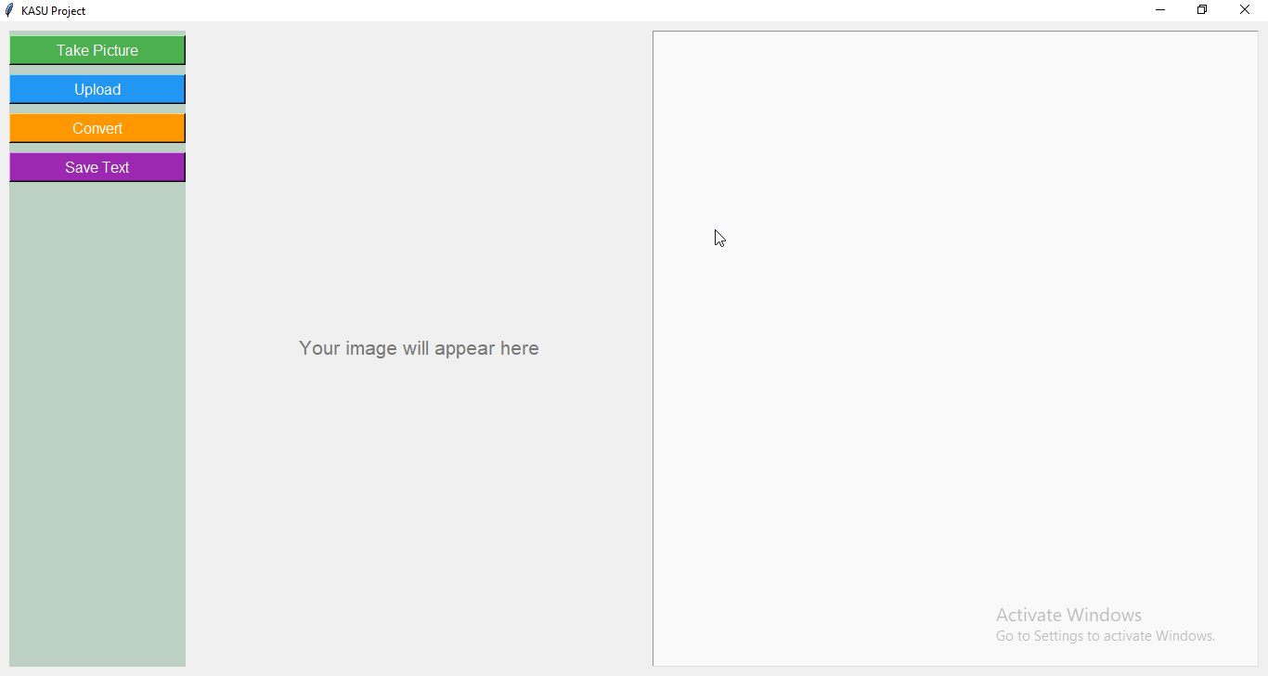
Figure 4.1 This shows the main screen of the system where users can upload images, view extracted text, and save the result. The interface is clean and easy to use.
Key features of the user interface include:
1. Image Upload:
The main feature of the UI is the image upload function. Users can easily upload documents by either dragging and dropping an image file or selecting it through a file picker. The system supports common formats like JPEG, PNG, and TIFF.
2. Image Preview:
Once an image is uploaded, a preview of the image is displayed on the screen. This helps users confirm that the correct document has been selected and allows them to see the quality of the image before processing.
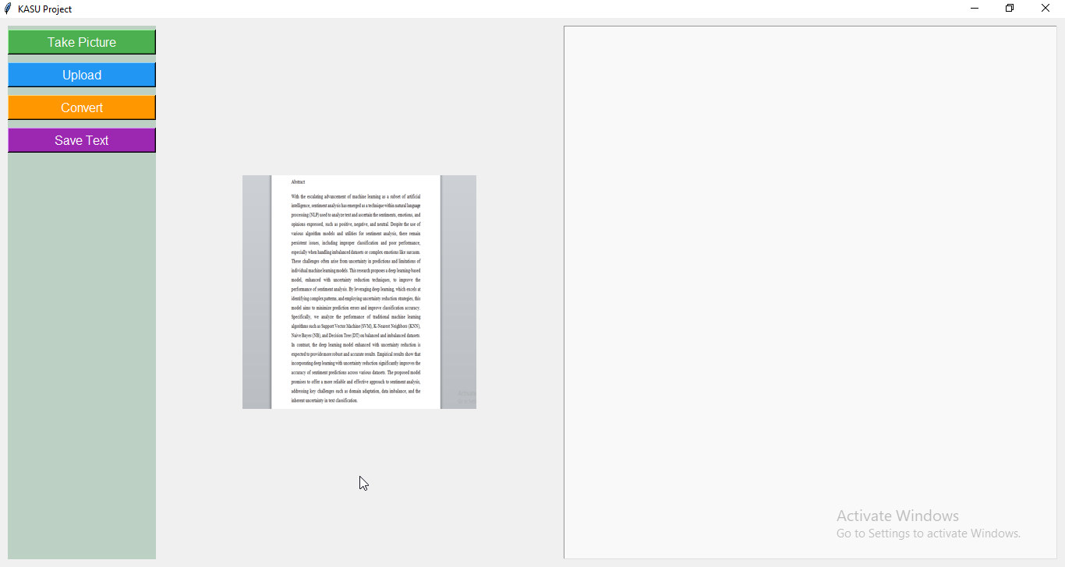
Figure 4.2 This figure displays how a user selects and uploads an image for processing. It supports common image formats like JPG and PNG.
3. Text Display:
After the OCR engine processes the image, the extracted text is displayed in a text box within the UI. This allows users to view the recognized text immediately. The interface also highlights any errors or areas where the OCR might have struggled (such as unrecognized characters).
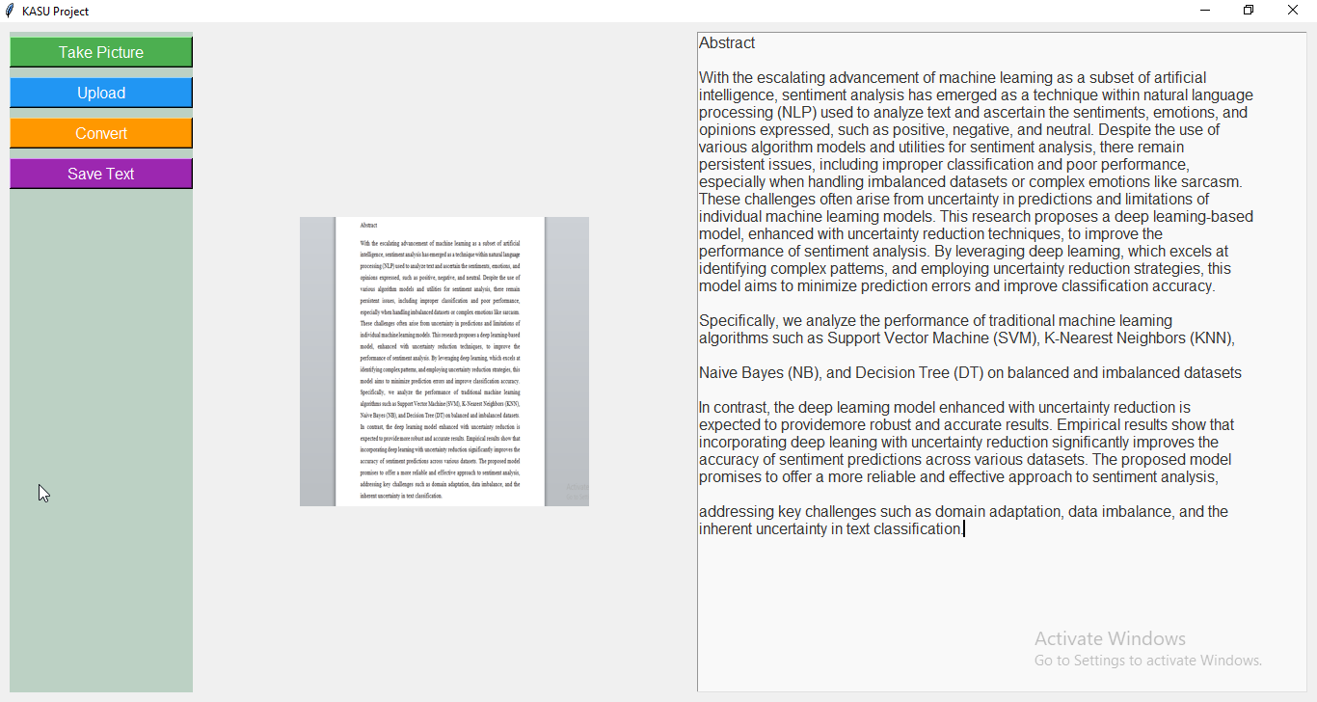
Figure 4.3 After uploading, this shows the text that has been successfully extracted from the image using OCR.
4. Save/Export Options:
Once the text is extracted and displayed, users have the option to save or export the text. The system can generate outputs in editable formats like DOCX, which users can then download or open in any word processor.
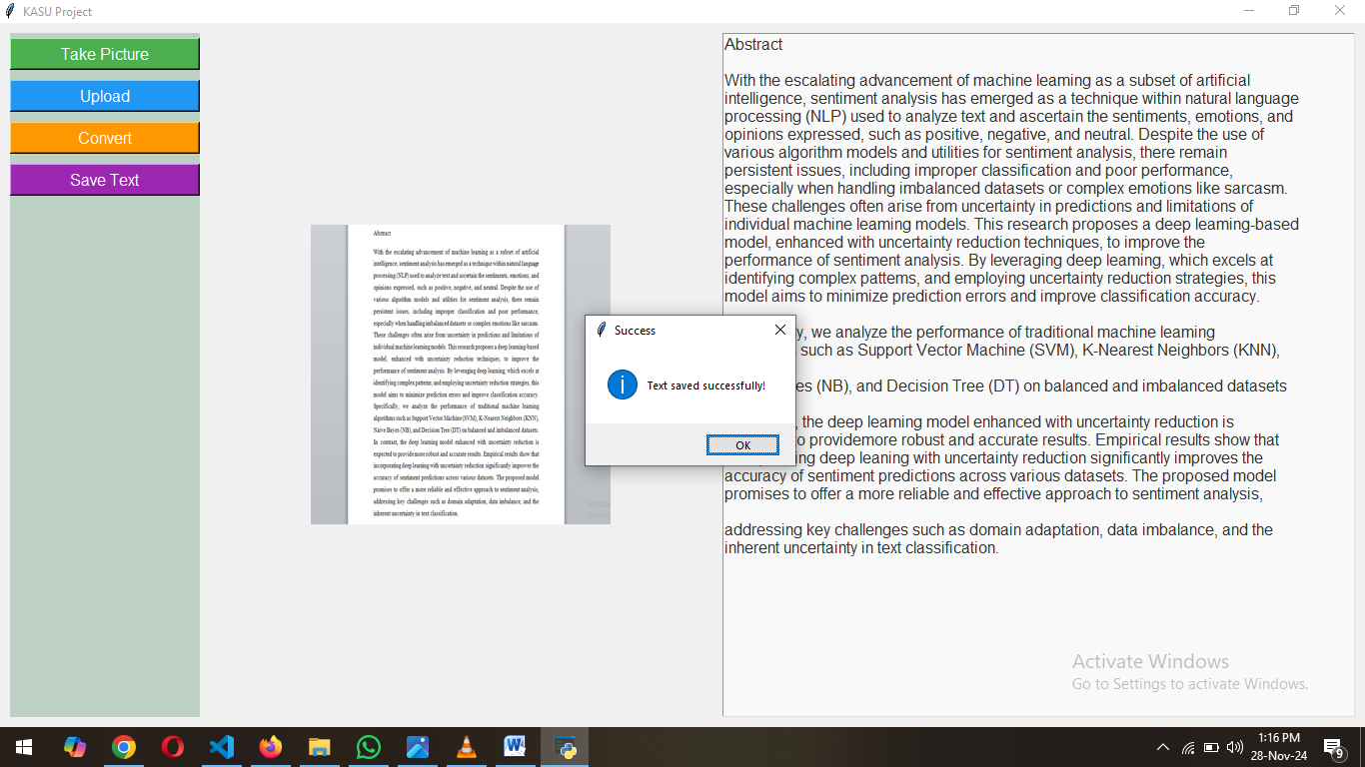
Figure 4.4 This shows the option to save the extracted text into a document file, like DOCX, for editing or storage.
5. Simple Navigation:
The layout is kept simple, with a few buttons and menus that guide the user through the process of uploading, processing, and saving documents. There are no unnecessary features to avoid overwhelming the user, especially for those without technical expertise.

4.5 OCR and Image Processing Integration
The integration of Tesseract OCR and OpenCV is one of the most critical aspects of the Intelligent Document Management System for Automated Digitization. This section explains how these two components work together to process and extract text from uploaded images, ensuring high accuracy and efficiency.
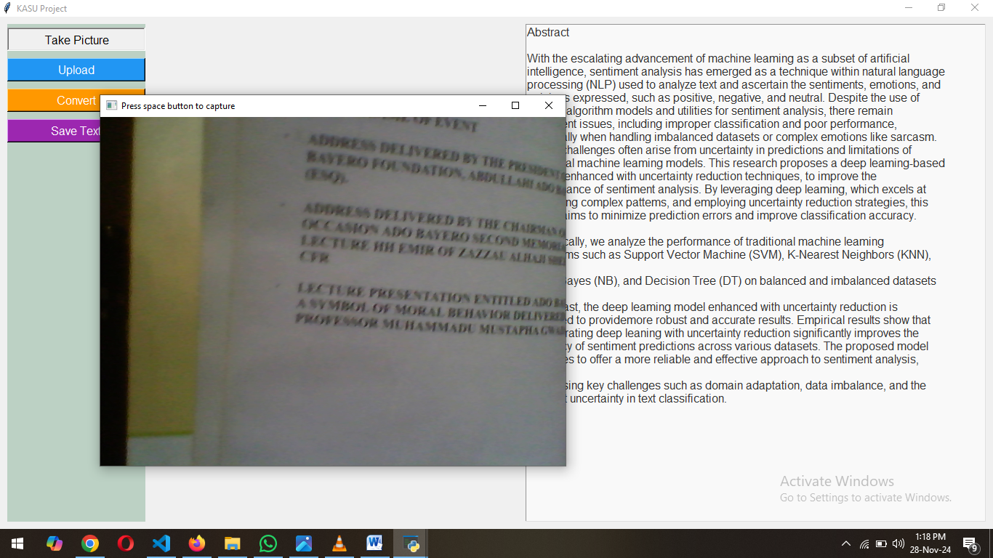
Figure 4.5 This figure shows the system capturing a document image directly from a connected camera for real-time
1. Image Preprocessing with OpenCV:
Once the image is uploaded by the user, the system uses OpenCV to preprocess the image before it is passed to the OCR engine. The preprocessing steps involve:
- Resizing: Adjusting the image size to a consistent resolution to improve OCR accuracy.
- Binarization: Converting the image to black and white, making it easier for the OCR engine to detect text.
- Noise Reduction: Applying filters to reduce image noise and enhance the text's clarity.
- Skew Correction: Aligning the image correctly to ensure that the text is oriented properly for extraction.
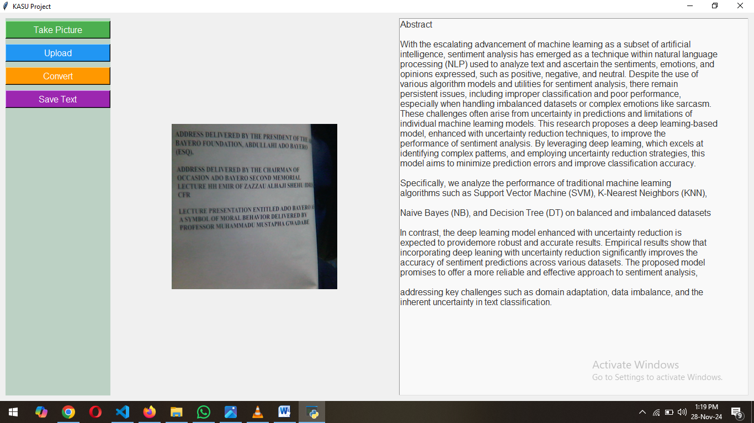
Figure 4.6 This image shows another example of text extracted using the live camera feature, demonstrating accurate recognition from captured documents.
2. OCR Text Extraction with Tesseract:
After preprocessing, the cleaned image is sent to Tesseract OCR for text recognition. Tesseract analyzes the image, detects the text, and converts it into machine-readable characters. The OCR engine can handle different languages and fonts, making it adaptable to a variety of documents, including printed text and simple handwriting.
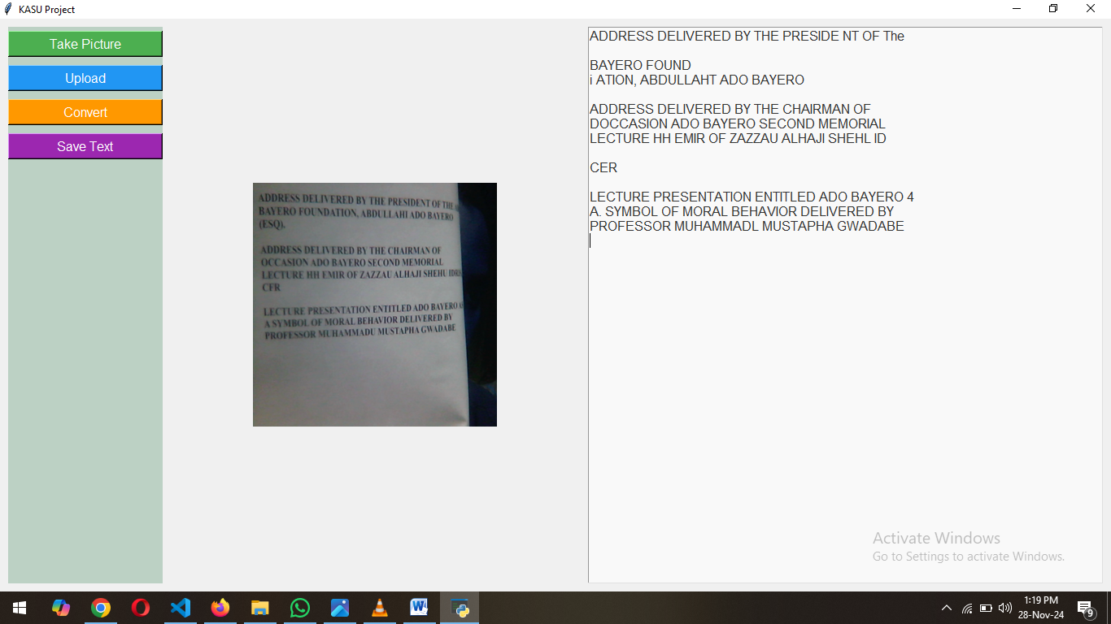
Figure 4.7 extracted text from live camera
3. Text Recognition and Error Handling:
During OCR, Tesseract may occasionally fail to recognize certain characters due to poor image quality or complex fonts. In such cases, the system logs errors and highlights unrecognized text for user review. This error handling ensures that users are aware of any limitations in the OCR process.
4. Integration with Output Generation:
Once the text is successfully extracted, it is automatically passed to the output generation module. The seamless integration between OCR and the output module ensures that the system can generate a final document quickly and accurately.

4.6 Output Generation and Formatting
The output generation process is responsible for converting the text extracted by OCR into a structured, editable format. Once the OCR engine extracts the text from the processed image, it is formatted into a user-friendly document that can be saved and edited as needed.
1. Text Formatting:
After the text is extracted, the system uses the python-docx library to format the text into a DOCX file. This process includes:
- Preserving Text Structure: The system tries to maintain the original structure of the document (e.g., paragraphs, headings, and bullet points). This ensures that the text is not only readable but also organized in a familiar format for users.
- Text Adjustments: The system makes adjustments where necessary, such as correcting text alignment or removing redundant spaces that may have resulted from the OCR process.
2. Handling Complex Documents:
For documents with more complex layouts (such as forms or documents with tables), the system attempts to extract and preserve these structures in the generated DOCX file. While some layouts may not be perfectly replicated, the system tries to maintain as much of the original formatting as possible.
3. Output File Options:
Once the text is formatted, users can save the document in DOCX format. The system allows users to download or directly open the file in a word processor for further editing.
4. Final Document:
The final output is a fully formatted, editable document, ready for use. Users can view, modify, and save the document based on their needs.

4.7 Testing and Debugging
Once the system was developed, thorough testing and debugging were crucial steps to ensure that the Intelligent Document Management System for Automated Digitization operates as expected and delivers accurate results. This section outlines the testing process and the steps taken to debug and resolve issues that arose during development.
1. Unit Testing
Unit testing focused on verifying the individual components of the system. Each function and module was tested separately to ensure that it works correctly before being integrated into the larger system. Key areas tested included:
- OCR Functionality: Verifying that Tesseract OCR accurately extracted text from various document types (printed, handwritten, mixed content).
- Image Preprocessing: Ensuring that OpenCV functions like noise reduction, skew correction, and binarization improved the image quality and facilitated better OCR results.
- UI Elements: Ensuring that buttons, image upload functionality, and text output displays were responsive and worked as intended.
2. Integration Testing
After successfully testing individual components, integration testing was conducted to ensure that all system modules (image upload, preprocessing, OCR, output generation, UI) worked together as expected. This step was crucial for identifying any issues with data flow between components. For example, ensuring that:
- The image uploaded by the user correctly passes through the preprocessing module.
- The preprocessed image is accurately processed by the OCR engine.
- The extracted text is then passed to the output generation module and formatted properly.
3. User Acceptance Testing (UAT)
User Acceptance Testing (UAT) was conducted with real users to ensure that the system meets the functional requirements and provides a user-friendly experience. During UAT, participants tested the system with sample documents and provided feedback on:
- Ease of Use: How easy it was to upload documents and view the extracted text.
- Accuracy: How accurately the system extracted text from the documents.
- Speed: The time it took to process documents and generate output files.
Feedback from UAT helped identify areas for improvement, especially regarding the layout of the user interface and the clarity of error messages.
4. Performance Testing
Performance testing was done to ensure that the system could handle large documents or multiple users without significant performance degradation. This included testing:
- Processing Time: How long it takes to process a document from image upload to output generation.
- System Load: How the system performs under stress, such as when processing multiple documents simultaneously or handling large file sizes.
5. Debugging
During the testing process, several bugs and issues were identified and resolved:
- OCR Accuracy: In cases where Tesseract struggled with handwriting or low-resolution images, adjustments to preprocessing steps were made to improve results.
- UI Issues: Minor UI glitches, such as buttons not responding or images not displaying correctly, were fixed through code revisions.
- Error Handling: Improved error messages were added to the system to provide clearer feedback to users in case of issues, such as unsupported file formats or processing failures.

